Peak Petroleum Industries Nigeria LTD
and
Equator Exploration Nigeria LTD

Offshore Nigeria Block OML 122

Bilabri D4
Addendum 2 to Well Plan Rev #1

Drilling 12-1/4” ‘S’ Shaped Pilot Hole in C2 Oil Sand to 2460m TVD RKB

Drilling Unit
Semisubmersible Bulford Dolphin

Signature Approvals:

Written By: ___________________________ Date: __________
Wali Adedotun
Drilling Engineer – Beta Development Team

Reviewed By:___________________________ Date: __________
Robert Montgomery
Drilling Project Manager – Beta Development Team

Approved By: ___________________________ Date: __________
Glyn Evans
Project Director – Beta Development Team

Approved By: ___________________________ Date: __________
Dr. Kenneth Seymour
Project Adviser – Beta Development Team

Approved By: ___________________________ Date: __________
Tony Gray or Bobby Roundtree
Drilling Superintendent – Beta Development Team

1. Change in 12-1/4” Hole Section Drilling Program

Discussion
The 12-1/4” hole section will be drilled as an ‘S’ Shaped trajectory from the 13-3/8” casing shoe to penetrate the C2 Oil Sand at a vertical angle to section TD at 2460m TVD / 2591m MD RKB. The directional trajectory is as per the BHI directional plots.

The ‘S’ Pilot Hole Target Coordinates to penetrate the C2 Oil Sand are as follows:
X = 730,328.54 East
Y = 514,670.10 North
Lat = 04 º 39’ 11.575” North
Long = 05 º 04’ 34.508” East
This Target Coordinate is the planned heel of the horizontal section which will be drilled at a later time during the completion phase of the well.

The 12-1/4” ‘S’ shaped pilot hole will be evaluated by LWD at the C2 Oil Sand followed by temporary abandonment.

2. Operations Summary

Drilling the 12-1/4” ‘S’ Shaped Pilot Hole
The 13-3/8” casing will be pressure tested to 1000 psi against the blind shear rams. The casing will be drilled out using a stabilized 12-1/4” BHA. The shoe will be tested to FIT of 12.0 ppg emw using 10.0 ppg SOBM. Drilling will commence with the standard BHA to 1200m TVD/MD RKB. This assembly will be pulled. A BHI 9-1/2” OD AutoTrac Steerable Assembly with MWD/LWD Triple Combo will be run with a short gauge 12-1/4” Hughes PDC bit.

The 12-1/4” hole will be kicked off at 1300m MD RKB and the pilot hole will be drilled at a build rate of 3.0º/30m at 37.5º to 2300m TVD / 2431m MD RKB. The well trajectory will be dropped at 3.0º/30m. The C2 penetration will be drilled vertical through the C2 Reservoir to 2460m TVD / 2591m MD RKB. The mud weight will be controlled as required to maintain hole stability and limit overbalance to formation pressure. Anticipated mud weight of the SOBM will be 10.0 ppg with a 9.1 ppg pore pressure.

An Optional Gyro Survey will be run inside the 5” drill pipe using the Baker Atlas Wireline unit to be used as additional survey data to back up the MWD surveys. It is important to limit the uncertainty of the directional measurements for future planning of the horizontal landing.

The 12-1/4” hole will be plugged back with balanced cement plugs to cover all hydrocarbon bearing zones. Instructions for temporary suspension program will be sent to the rig.

3. Mud Program

12-1/4”  ‘S’ Pilot Hole | Para Drill System  Synthetic Oil Base Mud | Mud Weight: 10.0 ppg  Funnel Vis: 45-55 sec/qt  PV: 25 – 30  YP: 20 – 25  HPHT: <3  OWR: 75 / 25  ES: > 400  % Water: 25% | Para Drill utilizes a low toxicity mineral oil PARA-TEQ as a base fluid.  Follow BHI procedures on displacement to SOBM.  Rheological properties should be maintained within operational limits and careful attention paid to hole cleaning while drilling directional section.  Pump sweeps as required as per BHI recommendation to ensure removal of cuttings beds on low side of hole.  Ensure caution before pumping LCM or sweeps as not to interfere with LWD Performance.

4. Geological Surveys

BHI will provide AutoTrac MWD/LWD with GR/RES/Den during the drilling of the 12-1/4” Section. The service will provide the following:
1. Directional Surveys
2. Gamma Ray
3. Resistivity (2 curves Real Time and 4 curves memory)
4. Downhole Temperature
5. Density
6. Neutron Porosity (Caliper Corrected)
7. Downhole Vibration Monitoring

BHI LWD Data will be the main source of evaluation during the drilling phase. No Wireline logs are planned in the 12-1/4” hole section.

A fully computerized PetroLog Mudlogging Unit staffed by two data engineers, 1 ADT, and two sample catchers will be fully rigged up before drilling out of the 13-3/8” casing.

Sample Interval
Samples are to be taken every 10m from casing shoe down to the top of reservoir sections and at 3m intervals thereafter to the 12-1/4” section TD. The sampling intervals are to be followed unless the Wellsite Geologist decides that operational procedures dictate otherwise. Spot samples will be taken at the request of the Wellsite Geologist.

Wet Cuttings Samples
Five (5) sets of unwashed wet cuttings should be collected in plastic lined cotton bags.

Washed and Dried Samples
Four (4) sets of washed and dried cuttings should be collected in paper envelopes.

5. Well Plan Outline
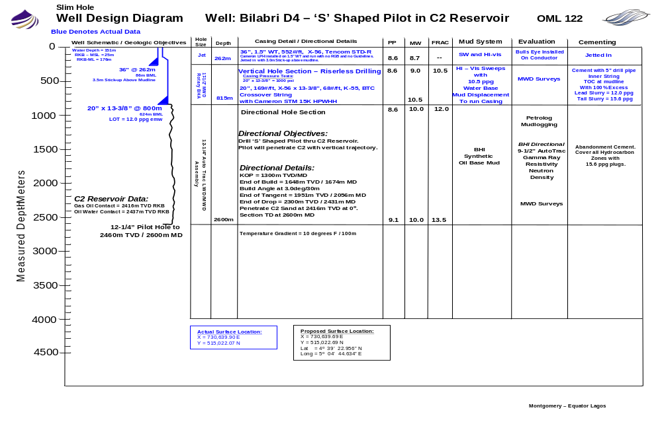
BHI Directional Plot – S Pilot Hole into C2 OS: Penetration of C2 OS at 0 degrees hole angle with KOP at 1300m TVD

6. Peak Geological Prognosis
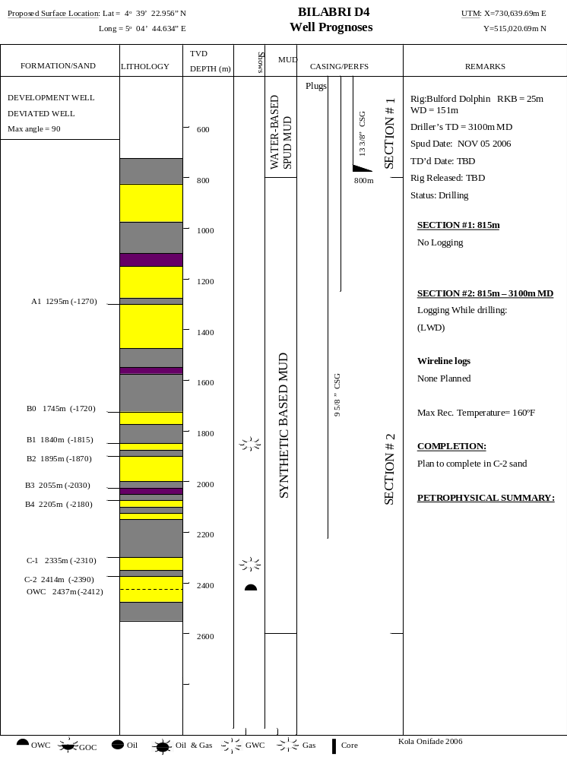
7. Drilling Procedures

Drilling 12-1/4” ‘S’ Shaped Pilot Hole
Operational Notes:
Total Depth of Section: Drill ‘S’ Shaped trajectory to penetrate the C2 Oil Sand vertical to Section TD at 2460m TVD / 2591m MD
Drilling Fluid: 10.0 ppg SOBM
FIT Expected at 13-3/8” shoe: 12.0 ppg emw
Pressure Details: No overpressure expected. Pore Pressure of C2 sand is 9.1 ppg.
Section TD Criteria: LWD log of C2 Oil Water Contact

Well Control
Flow check all drilling breaks with drill string spaced out in stack. While drilling ahead, line up stack with failsafe valves closed and hydraulic chokes closed. If flow from well is detected, shut well in with Upper Annular. Line up to monitor wellbore through choke line against closed choke. Circulate to kill well using Drillers Method. Discontinue boosting riser during each connection to enable static flow check before making connections.

Directional Drilling Guidelines
Initial KOP at 1300m TVD / 1300m MD RKB
Build angle at 3.0º/30m to 37.47º at azimuth 222º to 1649m TVD / 1675m MD RKB
Hold Tangent angle of 37.47º to 1951m TVD / 2056m MD RKB
Drop into target at 3.0º/30m from 37.5º to 0º. Section TD at 2460m TVD / 2591m MD RKB

The target sands are highly porous and permeable, weakly cemented, and relatively unconsolidated. Formation damage to these sands can occur easily and as a result has to be reduced to a minimum. Wellbore stability is also a problem, not only from an inhibition perspective, but also from any unnecessary induced forces.

Follow good drilling practices – minimize surge and swab pressures on connections and trips to avoid mud losses. Bring mud pumps online slowly to avoid surging while cycling the MWD/LWD tools. Ream and wash connections as required to avoid hole packoff. Keep pipe moving at all times to minimize differential sticking.

It is important to pump out of the hole at all times and to backream as required so as to remove cuttings beds from the low side of the hole.

General Procedure to drill 12-1/4” ‘S’ Pilot Hole:

- Prepare for SOBM mud displacement. Clean mud pits and take on 10.0 ppg SOBM as necessary for displacement.

- Make up the following 12-1/4” Stabilized Drilling Assembly:
12-1/4” MXCS Rock Bit, IADC 117, Nozzles 3x20, 1x22C
Float Sub with ported float
(1) 8” OD Drill Collar
12-1/4” Stabilizer
(1) 8” OD Drill Collar
12-1/4” Stabilizer
(5) 8” OD Drill Collar
7-3/4” OD Drilling Jars
(2) 8” OD Drill Collar
Crossover Sub
(17) 5” HWDP

- RIH with 12-1/4” BHA. Drill out shoe track to within 2m of float shoe. Displace hole with 10.0 ppg SOBM. Drill out shoe. Clean rathole. Drill 2m of new hole. Circulate and condition mud. Pull back to shoe and space out in BOP. Perform FIT to 12.0 ppg emw using BJ unit. Pump down top drive at ¼ bpm. Record data and check with Drilling Superintendent in Lagos on results.

- Drill ahead with 12-1/4” Stabilized Drilling Assembly – No MWD/LWD. Drill to +/-1200m RKB. Circulate hole clean. Perform wiper trip if required. POOH with 12-1/4” assembly.

- Make up the following 12-1/4” AutoTrac LWD/MWD Rotary Assembly:
12-1/4” PDC Bit – Hughes Type HCM 507Z with TFA 1.2
9-1/4” AutoTrac G3.0 with 12-1/8” NM Stab/Flex Sub
9-1/2” ONTRAK
11-3/4” Modular Stab
9-1/2” Pulser Sub
Crossover Sub
8-1/4” LWD/MWD ORD/CCN – GR/RES/Den/Neutron
12-1/8” NM String Stab
(1) 8” OD NMDC
Float Sub
Crossover Sub
(13) 5” HWDP
6-1/8” OD Drilling Jar
(4) 5” HWDP

- RIH. Take check shot MWD surveys every 150m from 13-3/8” shoe to +/-1200m RKB (Or as directed by BHI Directional Driller). Wash down to bottom with last 2 stands. Circulate hole clean.

- Continue to directionally drill 12-1/4” ‘S’ Pilot Hole as per BHI Directional Trajectory and as directed by directional driller. Drill to section TD at 2460m TVD / 2591m MD RKB. Pump at flow rates of +/-750 gpm as required for AutoTrac and MWD/LWD. Mud weight at section TD is prognosed to be 10.0 ppg.

- At section TD, perform dummy connection and circulate out to check gas levels. Circulate bottoms up and boost to clean riser. Pump low vis / high weight / low sweeps to clean hole if required. DO NOT ATTEMPT TO PULL PIPE. ALWAYS BACKREAM OR PUMP OUT OF HOLE – TO ENSURE ALL CUTTINGS BEDS ARE REMOVED. Pump out of hole to 13-3/8” shoe at drilling flow rate. Circulate bottoms up to above stack.

- Circulate hole clean. POOH. Flow check well for 10 minutes at 13-3/8” shoe. POOH with 12-1/4” BHA. Download LWD at rotary. Lay down BHI Tools.

- OPTIONAL PROCEDURE TO RUN GYRO SURVEY IN DRILL PIPE: Make up stabilized BHA as per BHI Directional Driller. RIH to bottom. Circulate hole clean. Rig up Baker Atlas Wireline Unit. Run gyro survey through drill pipe. Send in both BHI MWD Surveys and Gyro Data.

- Prepare to plug back open hole with cement plugs – PROGRAM TO BE DETERMINED AFTER RESULTS OF LWD LOG. Set temporary cement plugs as per Peak Abandonment Program to be submitted.

- Make up Cameron Wear Bushing Running Tool with jet sub on (3) stands of HWDP. RIH. Jet BOP and wellhead area and boost riser clean. Retrieve NSP.

- Pull Riser and BOP as per Dolphin Procedures. Install Corrosion Cap on 18-3/4” wellhead. Perform seabed survey to 100m radius from wellbore with ROV.

- Prepare to pull anchors.

- Special Procedures will be sent to the rig as required.

